**PROJECT REPORT**

**1.INTRODUCTION**

* 1. Overview:

**Wholesaling is the act of buying goods in bulk from a manufacturer at a discounted price and selling to a retailer for a higher price, for them to repackage and in turn resell in smaller quantities at an even higher price to consumers.**

**The wholesale trade comprises purchasing, storing, and selling merchandise to retailers or to other wholesalers and providing related services such as breaking bulk.**

1.2 Purpose:

**Wholesalers purchase goods in bulk from manufacturers, store them and distribute them to retailers in small quantities for further wholesales. This bulk purchase of goods enables manufacturers to undertake production on a large scale without worrying about storage facilities.**

**Wholesalers not only provide warehousing facilities such as collection, storage and protection of goods but also facilitate marketing and distribution creating time utility.**

**2.Problem Definition & Design Thinking**

2.1 Empathy Map:

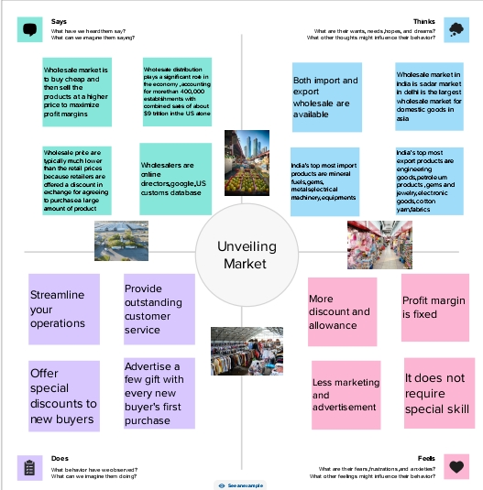

2.2 Ideation & Brainstorming map:

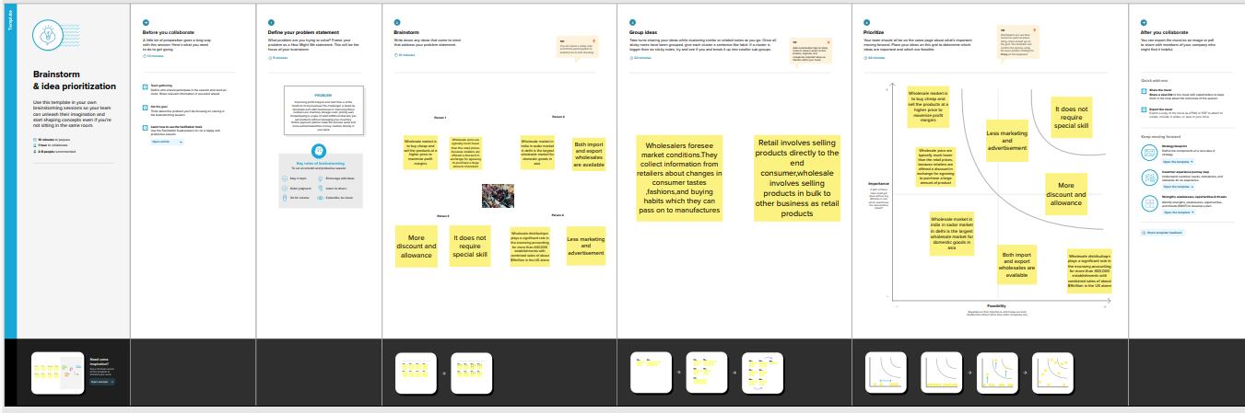

**3.RESULT:**

3.1DASHBOARD

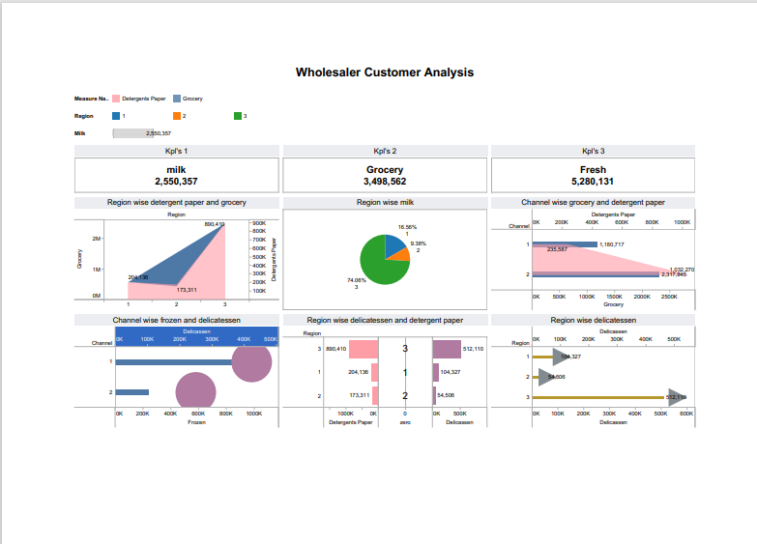

https://public.tableau.com/views/unveilingmarket/Dashboard1?:language=en-US&:display_count=n&:origin=viz_share_link

3.2 Region wise detergent paper and grocery:

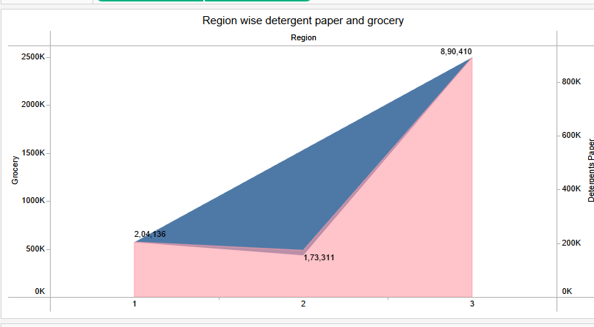

3.3 Region wise delicatessen and detergent paper:

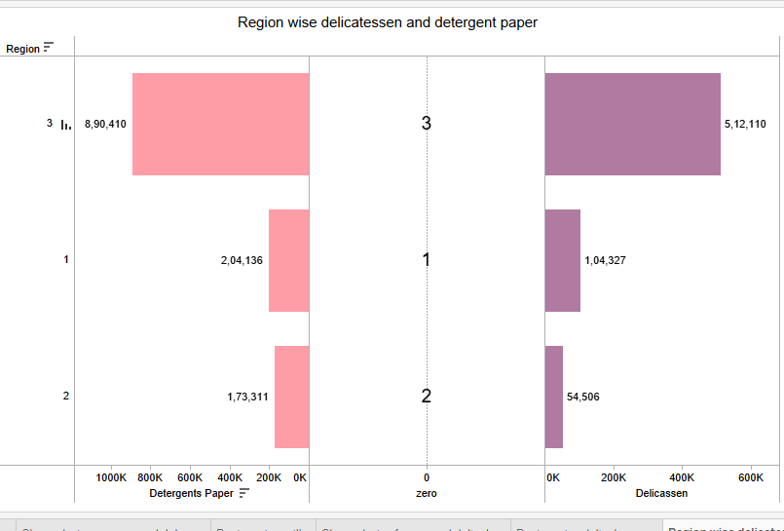

https://public.tableau.com/views/unvellingmarketstory/Story1?:language=en-US&:display_count=n&:origin=viz_share_link

**4.ADVANTAGES & DISADVANTAGES:**

Advantages:

1.More discount and allowance:

**Wholesalers buy large quantity of goods from manufactures. They can receive cash discount and quantity because of bulk buying. It helps to reduce buying cost and increase profit. So, wholesale business enjoys the benefit of large scale buying**

2.Profit margin is fixed:

**Wholesalers do not need to worry about the profit because they can earn fixed rate of profit. So, they should try to increase sales volume which helps to increase earnings.**

3. Less marketing and advertisement:

**Generally producers market their products by using different methods of advertising. Retailers also use product display and demonstrations to attract potential customers. Wholesalers do not need such marketing activities because they buy from manufactures and supply to retailers. So, it helps to eliminate marketing costs.**

4.Less competition:

**Wholesale business does not face tough competition in the market because each wholesaler deals with specific product line from certain producer. So, there is less competition because of limited product line and fewer number of wholesalers.**

5.It does not require special skill:

**Wholesalers do not deal with final consumers. So, they do not require selling skills to attract customers like in retailing.**

Disadvantages:

1.It requires huge capital:

**Huge amount of capital is required to start wholesale business. It requires sufficient fund to buy large volume of goods. Adequate level of stock should be maintained to avoid shortage of product in the market. Truck or delivery van is required to deliver goods to different retail stores., So, it cannot be commenced with little investment.**

2.Needs more space:

**It requires more space to store large quantity of goods. Wholesalers need to spend huge storing expenses due to high commercial rent.**

3.Less profit margin:

**There is less profit margin in wholesale business than in retailing. Usual wholesalers earn 2% to 8% profit on sale, but retailers may enjoy 10% to 20% profit.**

4.Possibility of loss:

**Large quantity of goods should be kept in the store room safely and properly. Water, fire, and insects can damage the products. In this situation wholesalers have to face huge financial loss.**

5.No direct interaction with customers:

**As we know that wholesalers do not sell goods to the final customers, it means there is no interaction between wholesalers and customers. So, wholesalers cannot understand the interests and preferences of audience.**

**5.APPLICATIONS:**

**The solutions gathered from this project can be applied in the following areas:**

**\*Reducing per unit marketing costs.**

**\*Promotes stable markets for local produce.**

**\*Encourages increased output and productivity.**

**6.CONCLUSION:**

**In conclusion, this project enhancing transparent price discovery and facilitating transactions in the marketing chain. Reducing post- harvest losses and promoting increased use of standard weights and measures. Promotes stable markets for local produce. If the customer purchases a product from a wholesaler, he will be charged for a drop shipment, which will be charged to both the buyer and the wholesaler.**

**7.FUTURE SCOPE:**

**Future enhancements for this project could include:**

**\*optimize your website.**

**\*Offer enticing deals.**

**\*Plan effective marketing strategies.**

**\*Invest in a good delivery system.**